本期内容：
- Spark Streaming on polling from Flume实战
- Spark Streaming on polling from Flume源码
FlumeConnection:分布式连接的Flume实体
推模式(Flume push SparkStreaming) VS 拉模式(SparkStreaming pool flume）
推模式:推模式的理解就是Flume作为缓存，存有数据，监听对应端口，如果服务可以链接，就将数据push过去（简单，耦合要低）缺点就是SparkStreaming程序没有启动的话，Flume端会报错，同时会导致Spark Streaming程序来不及消费的情况
采用拉模式:拉模式就是自己定义一个sink,SparkStreaming自己去channel里面取数据，根据自身条件去获取数据，稳定性好。
如果是push的状态，如果sparkStreaming程序没有起来的话，flume会报错，这个报错非常简单的原因就是flume是push数据到sparkStreaming所指定的端口
今天讲SparkStreaming从flume poll数据，如果Spark Streaming消费不及数据，那么就直接自己控制
Spark本身就是做机器学习，最擅长的就是机器学习的版本
I.实战
- 通过Spark Streaming主动从Flume这边获取数据，首先配置Flume-config配置文件
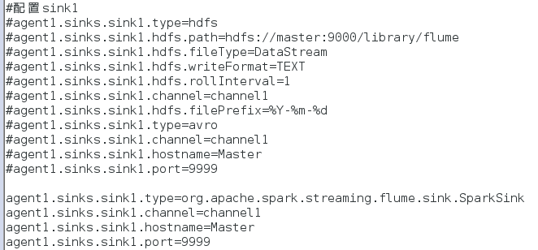
- 编写源代码SparkStreamingPullFlume.java
package com.dt.spark.SparkApps.SparkStreaming;
import java.util.Arrays;
import org.apache.spark.SparkConf;
import org.apache.spark.api.java.function.FlatMapFunction;
import org.apache.spark.api.java.function.Function2;
import org.apache.spark.api.java.function.PairFunction;
import org.apache.spark.streaming.Duration;
import org.apache.spark.streaming.Durations;
import org.apache.spark.streaming.api.java.JavaDStream;
import org.apache.spark.streaming.api.java.JavaPairDStream;
import org.apache.spark.streaming.api.java.JavaReceiverInputDStream;
import org.apache.spark.streaming.api.java.JavaStreamingContext;
import org.apache.spark.streaming.api.java.JavaStreamingContextFactory;
import org.apache.spark.streaming.flume.FlumeUtils;
import org.apache.spark.streaming.flume.SparkFlumeEvent;
import scala.Tuple2;
public class SparkStreamingPullFlume {
public static void main(String[] args) {
final SparkConf conf = new SparkConf().setMaster("local[4]").setAppName("FlumePushDate2SparkStreaming");
JavaStreamingContext jsc = new JavaStreamingContext(conf, Durations.seconds(30));
JavaReceiverInputDStream<SparkFlumeEvent> lines = FlumeUtils.createPollingStream(jsc, "Master", 9999);
JavaDStream<String> words = lines.flatMap(new FlatMapFunction<SparkFlumeEvent, String>() {
private static final long serialVersionUID = 1L;
public Iterable<String> call(SparkFlumeEvent arg0) throws Exception {
String line = new String(arg0.event().getBody().array());
return Arrays.asList(line.split(" "));
}
});
JavaPairDStream<String, Integer> pairs = words.mapToPair(new PairFunction<String, String, Integer>() {
public Tuple2<String, Integer> call(String arg0) throws Exception {
return new Tuple2<String, Integer>(arg0, 1);
}
});
JavaPairDStream<String, Integer> wordsCount = pairs.reduceByKey(new Function2<Integer, Integer, Integer>() {
public Integer call(Integer v1, Integer v2) throws Exception {
return v1 + v2;
}
});
wordsCount.print();
jsc.start();
jsc.awaitTermination();
jsc.close();
}
}
- 安装三个jar包到flume的lib目录下
commons-lang3-3.3.2.jar,scala-library-2.10.4.jar,spark-streaming-flume-sink_2.10-1.6.1.jar

- 运行eclipse中的程序SparkStreamingPullFlume.java
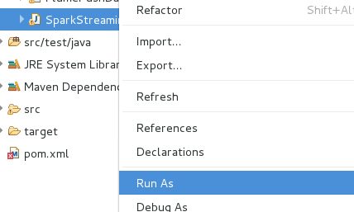

- 运行flume-ng
./flume-ng agent -n agent1 -c conf -f/usr/local/flume/apache-flume-1.6.0-bin/conf/flume-conf.properties -Dflume.root.logger=DEBUG,console
- 将hello.txt拷贝到/usr/local/flume/apache-flume-1.6.0-bin/tmp/TestDir/下面
Hello Spark
Hello Hadoop
Hello Kafka
Hello HDFS
六.获得运行结果
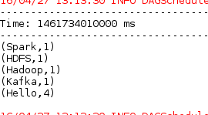
II.源代码分析
- 创建createPollingStream:
/**
* Creates an input stream that is to be used with the Spark Sink deployed on a Flume agent.
* This stream will poll the sink for data and will pull events as they are available.
* This stream will use a batch size of 1000 events and run 5 threads to pull data.
* @param hostname Address of the host on which the Spark Sink is running
* @param port Port of the host at which the Spark Sink is listening
* @param storageLevel Storage level to use for storing the received objects
*/
def createPollingStream(
ssc: StreamingContext,
hostname: String,
port: Int,
storageLevel: StorageLevel = StorageLevel.MEMORY_AND_DISK_SER_2
): ReceiverInputDStream[SparkFlumeEvent] = {
createPollingStream(ssc, Seq(new InetSocketAddress(hostname, port)), storageLevel)
}

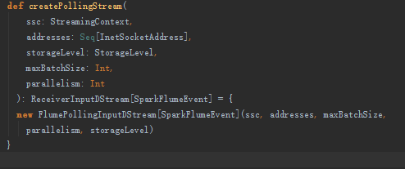
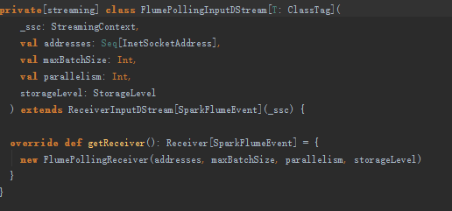
继承自ReceiverInputDstream中覆写getReciver方法，调用FlumePollingReciver接口
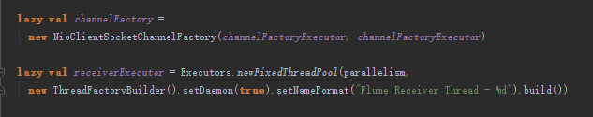
使用lazy和工厂方法创建线程和Nio客户端socket
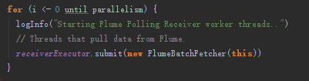
工作线程从Flume Polling中pull 数据，实质上是从消息队列中获取数据
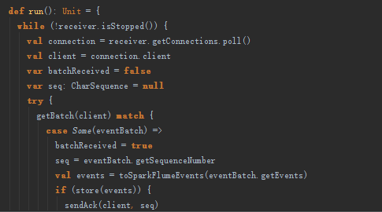
看run()方法中的receiver.getConnections.poll()中的poll方法:
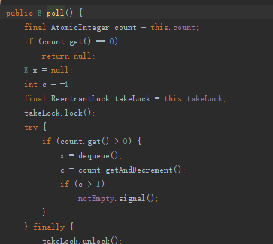
发现dequeue出消息队列:进入dequeue中观察奇妙的现象出来了发现enqueue投递消息队列中我们发现调用enqueue方法的地方
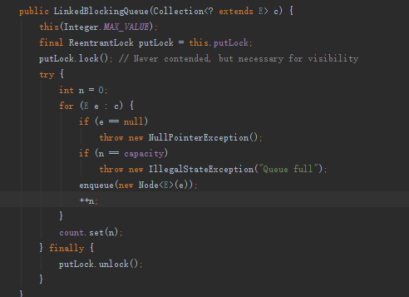
发现flemPollingInputDstream.scala中，初始化LinkedBlockingQueue[FlumeConnection]()

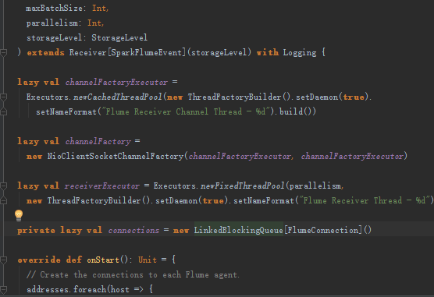
在onStart()方法中

其中
sendNack(batchReceived, client, seq)
}
case exception: Exception =>
logWarning("Error while receiving data from Flume", exception)
sendNack(batchReceived, client, seq)
sendNack,sendAck个人理解像tcp三次握手协议一样，传输协议之际数据传输的互相约定
载回头看poll接口其实就是从消息队列中获取要处理的数据
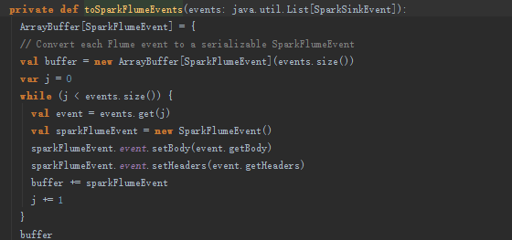

poll：监听数据链接端口，获得数据后放入收入消息的线程的主消息队列中，然后分发到工作线程的消息队列中进行数据提取

